**[DHT Sensor](https://robu.in/product/dht11-temperature-and-humidity-sensor-module-with-cable/" \t "_blank)-** From this sensor we can get values of temperature [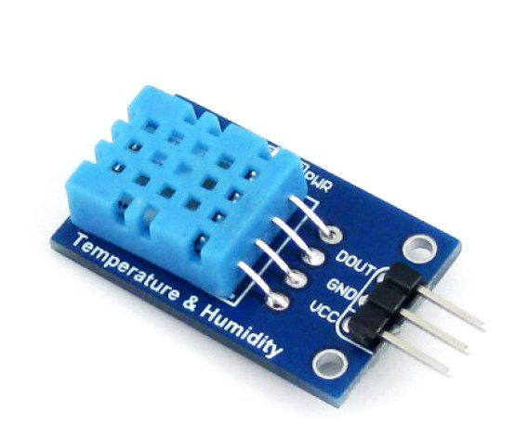](https://robu.in/wp-content/uploads/2020/11/DHT11.jpg)and humidity

* [**MQ-9 Gas sensor**](https://robu.in/product/mq-9-carbon-monoxide-methane-lpg-gas-sensor-module/)- To sense the content of CO gas in the environment

[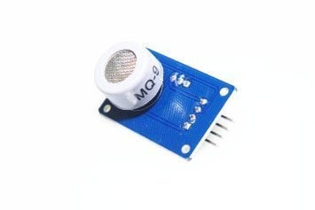](https://robu.in/wp-content/uploads/2017/09/mq-9-co-carbon-monoxide-methane-liquefied-gas-sensor-500x500.jpg)

* [**Water Pump**](https://robu.in/product/5v-noiseless-mini-submersible-pump-with-dc-5mm-female-jack/) - Having same use as water pump

[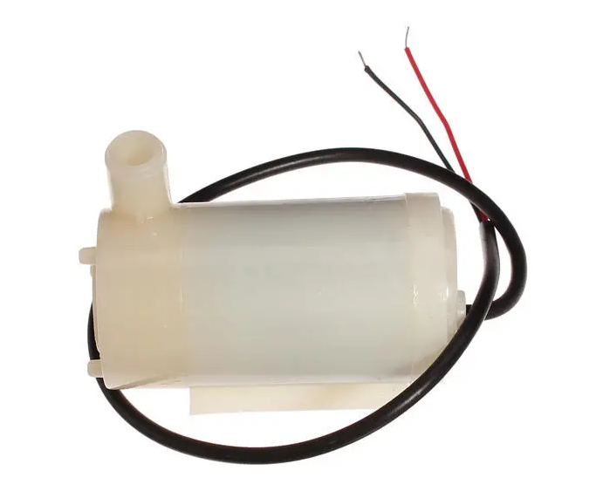](https://robu.in/wp-content/uploads/2020/11/waterpump.png)

* **2 Channel relay board** - Switch to trip high volt  AC/DC applicances

[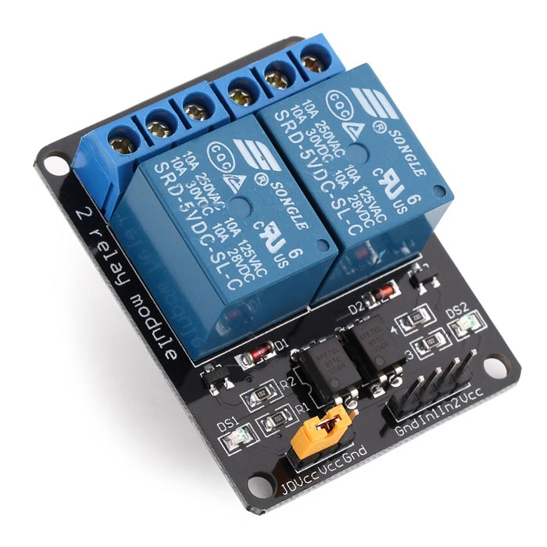](https://robu.in/wp-content/uploads/2020/11/2Channel_Relay.jpg)

* [**Exhaust fan**](https://robu.in/product/12v-3010-cooling-fan-for-3d-printer/) - To control farm's temperature

[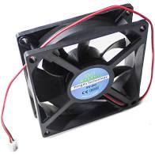](https://robu.in/wp-content/uploads/2020/11/Fan.jpg)

* [**Slide switch**](https://robu.in/product/4mm-spdt-1p2t-slide-switch-pack-of-10/) - Used to switch between two modes, self and manual.

[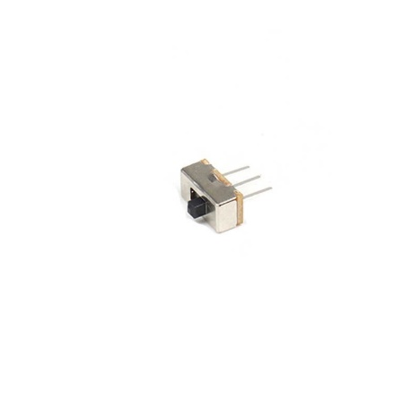](https://robu.in/wp-content/uploads/2019/10/4mm-SPDT-1P2T-Slide-Switch-5.jpg)

* [**Jumper wires**](https://robu.in/product/mb102-830-points-solderless-prototype-breadboard-power-supply-module-140-jumper-wires-arduino-diy-starter-kit/)- For making connections

[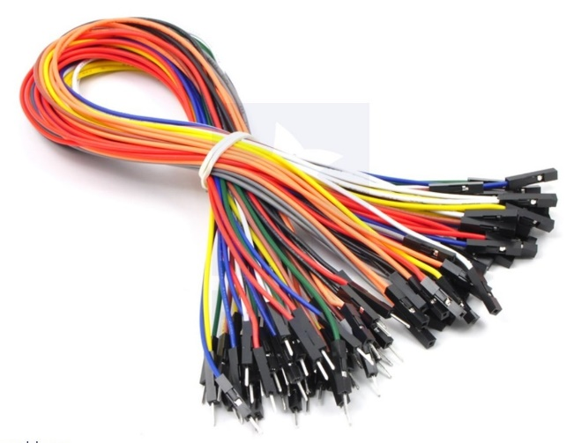](https://robu.in/wp-content/uploads/2020/11/JumperWires-1.jpg)